Processional
Grooms Grandparents__________________________________________________________ Brides Grandparents___________________________________________________________ Grooms Mom _______________________________escort____________________________ Brides Mom________________________________escort_____________________________
Officiant____________________________________________________________________ Groom _____________________________________________________________________ Best Man ___________________________________________________________________
Specify if Bridesmaids and Groomsmen are walking together or separately.
See Layout for placement
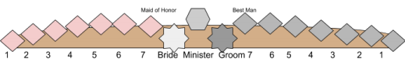Bridesmaid Groomsmen
1_____________________________________ 1__________________________________ 2_____________________________________ 2__________________________________ 3_____________________________________ 3__________________________________ 4_____________________________________ 4__________________________________ 5_____________________________________ 5__________________________________ 6_____________________________________ 6__________________________________
7. Maid of Honor _____________________________________________________________ 8. Ring Bearer________________________________________________________________ 9. Flower Girls________________________________________________________________
Bride _______________________________________ Dad ______________________________

